TEAM ID: PNT2022TMID08163

PROJECT NAME: DemandEst - AI powered Food Demand

Forecaster

TEAM LEADER

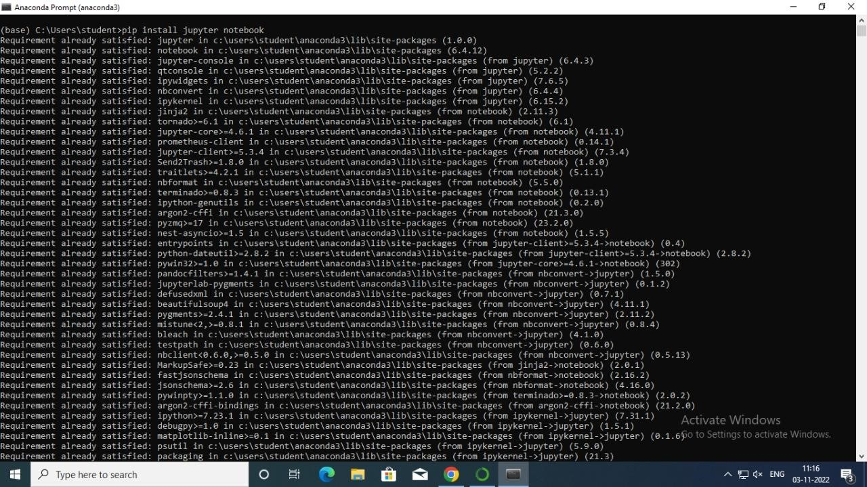

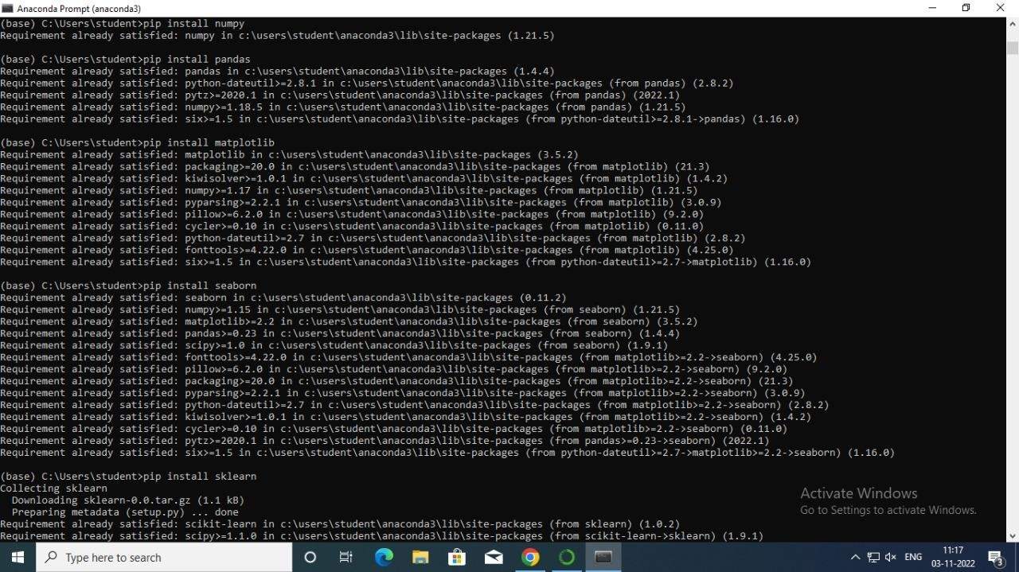

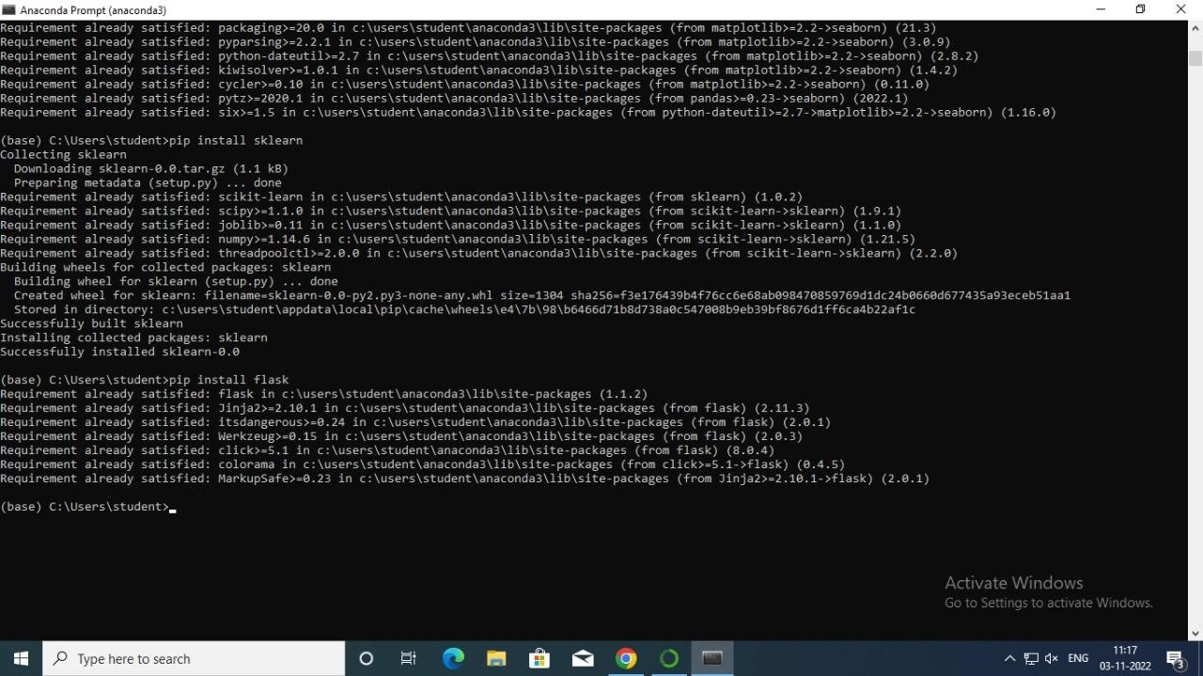

TEAM MEMBER 1



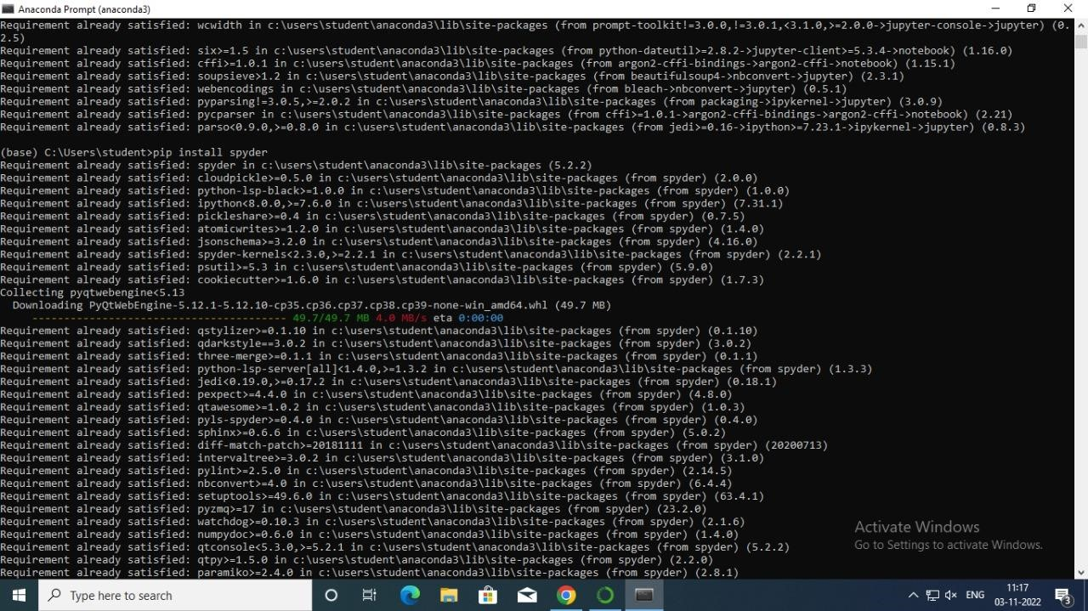



TEAM MEMBER 2







TEAM MEMBER 3

